ANOMALY DETECTION OF MOBILE TRANSACTIONAL DATA USING ISOLATION FOREST

ABSTRACT
This study investigates anomaly detection in mobile banking transactions using the Isolation Forest algorithm, a machine learning model renowned for its efficiency in identifying outliers in large datasets. We analyzed a dataset comprising 22,890,674 transactions from a single week in June 2024, focusing on detecting irregularities that could signal fraudulent activities or system malfunctions. The dataset underwent thorough preprocessing to handle missing values and inconsistencies, ensuring data quality. Key features such as total transaction amount, transaction frequency, deviations in debit amounts, and the mode of transactions were extracted to serve as input for the Isolation Forest model. The algorithm was able to effectively isolate outliers by creating an ensemble of decision trees that collectively distinguished normal transactions from anomalous ones. Our analysis revealed that 42,982 out of 4,298,320 debit accounts exhibited anomalous transaction behaviors, indicating potential security risks or operational issues. The findings demonstrate the Isolation Forest algorithm's robustness in handling high-dimensional financial data and its capability to support fraud detection in mobile banking systems. The results of this study underscore the importance of advanced anomaly detection methods in safeguarding financial transactions and enhancing the overall security framework of mobile banking platforms. This research contributes to the ongoing development of machine learning applications in financial security, offering a scalable and effective solution for anomaly detection in dynamic, high-volume transaction environments.

Key words: Anomaly, Anomaly Detection , Mobile Banking , Transactional Data

TABLE OF CONTENTS
ACKNOWLEDGEMENT i
Abstract ii
LIST OF FIGURES v
ACCRONYMS vi
CHAPTER ONE 1
1. INTRODUCTION 1
1.1. Background of the study 1
1.2. Statement of the problem 2
1.3. Objectives of the Study 3
1.3.1. General Objectives 3
1.3.2. Specific Objectives 3
1.4. Scope and Limitation of the Study 3
1.5. Significance of the study 3
1.6. Organization of the study 4
CHAPTER TWO 5
2. LITERATURE REVIEW 5
2.1. Mobile Banking 5
2.2. Anomaly Detection 5
2.3. Why is anomaly detection important in fraud prevention 6
2.4. Anomaly Detection Mechanism 7
CHAPTER THREE 9
3. METHODOLOGY 9
3.1. Chapter Overview 9
3.2. Research Design 9
3.3. Literature Review 10
3.4. Research Design 10
3.5. Data Collection 10
3.6. Tools and Techniques 10
CHAPTER FOUR 11
4. DATA COLLECTION, ANALYSIS AND DISCUSSION 11
4.1. Data Collection 11
4.2. Data preprocessing 11
4.3. Data Analysis 12
4.3.1. Transaction Diversity 12
4.2.1. Transaction Volume and Frequency 14
4.2.3. Transaction Patterns and Trends 16
4.4. Feature Extraction 18
4.5. Anomaly detection using Isolation forest 20
4.5.1. Feature Selection 21
4.6. Model result interpretation 22
4.6.1. Total Transaction Amount vs. Debit Amount Deviation std 22
4.6.2. Average Transaction Amount vs. Change in Transaction Amount 23
4.6.3. Rolling Average Amount vs. Transaction Velocity 24
4.6.4. Total Transaction Amount vs. Rolling Average Amount 25
4.6.5. Debit Amount Deviation Max vs. Average Transaction Amount 26
CHAPTER FIVE 28
5. CONCLUSION AND RECOMMENDATION 28
5.1. Conclusion 28
5.2. Recommendation 28
REFERENCES 30

LIST OF FIGURES

Figure 1: Architeccture of Anomaly detection using isolation forest 9
Figure 2: Extract data using python panda 11
Figure 3:Unique number of credit Account per customer 13
Figure 4: Unique number of transaction type by customer 14
Figure 5: Distribution of transaction amount 15
Figure 6:Houtly transaction count and Pike hour hightlight 16
Figure 7: Weekly tend of Transaction count and amount 17
Figure 8: Daily trend of Transaction count and amount 18
Figure 9:Isolation Forest Model Result 20
Figure 10: Total Transaction Amount vs. Debit Amount Deviation std 22
Figure 11: Average Transaction Amount vs. Change in Transaction Amount 23
Figure 12: Rolling Average Amount vs. Transaction Velocity 24
Figure 13: Total Transaction Amount vs. Rolling Average Amount 25
Figure 14: Debit Amount Deviation Max vs. Average Transaction Amount 26

ACCRONYMS

CBE Commercial Bank of Ethiopia
DEBIT_ACCT_NO Debit Account number
SVM Support Vector Machines
LOF Local Outlier Factor

CHAPTER ONE

INTRODUCTION

Background of the study
Mobile banking represents a significant advancement in financial services, enabling users to perform banking activities through their mobile devices, such as smartphones and tablets. This form of digital banking offers unparalleled convenience by allowing individuals to access their accounts, manage transactions, and receive customer support from virtually anywhere and at any time. Mobile banking applications typically provide features such as account management, fund transfers, bill payments, and real-time notifications, all of which enhance the efficiency of financial transactions and customer engagement (Agarwal, 2019). The technology underpinning mobile banking also incorporates advanced security measures, including multi-factor authentication and encryption, to safeguard users' financial information from cyber threats (Soo & Kim, 2018). Moreover, mobile banking plays a crucial role in promoting financial inclusion by extending services to underserved and remote populations, thereby bridging gaps left by traditional banking methods (Mertens & Adekoya, 2019).
The Commercial Bank of Ethiopia is the largest and oldest commercial bank in Ethiopia, playing a pivotal role in the country's banking sector. Established in 1942, the CBE serves as the primary financial institution, providing a wide range of banking services to individuals, businesses, and government entities (Commercial Bank of Ethiopia, 2024). According to 2023-24 annual report there is 4,957,762 customers , among them 29% are active users . It has been at the forefront of digital innovation in the banking sector, including the implementation of a CBE mobile banking. Recognizing the importance of mobile technology and its potential to enhance financial inclusion, the CBE introduced its mobile banking service to provide convenient and accessible financial services to a wider population in Ethiopia.
With the rapid expansion of mobile banking, fraudsters' tactics have become increasingly sophisticated, rendering traditional detection methods often ineffective. Advanced anomaly detection strategies, utilizing cutting-edge algorithms and machine learning, have emerged as crucial tools for identifying irregularities and potential fraud patterns in large datasets. These strategies enable the early detection of fraudulent activities, allowing for prompt intervention before significant harm occurs (Behera & Nayak, 2020))
Anomaly detection systems offer notable advantages over traditional methods. They are highly adaptable, capable of adjusting to evolving fraud patterns without the need for constant manual updates. This adaptability enhances the efficiency and responsiveness of fraud detection efforts (Bolton & Hand, 2002). Additionally, these systems can identify unknown or novel fraud patterns that might be overlooked by rule-based approaches, providing a more comprehensive defense against fraud (Phua & Gayler, 2010).
Moreover, Anomaly detection systems significantly enhance fraud prevention by reducing false positives through learning from normal user behavior, thereby improving accuracy and minimizing disruptions for legitimate customers. This integration is essential for addressing increasingly sophisticated fraud threats and maintaining robust security measures. Additionally, effective risk management is crucial for organizations to protect critical assets, involving the identification of threats, vulnerabilities, and potential impacts of information security incidents. Risk management encompasses assessing the likelihood of threats exploiting vulnerabilities, leading to losses in confidentiality, integrity, or availability, and understanding the resultant impact on business operations (Delamaire & De Ryck, 2009).

Statement of the problem
The rapid growth of mobile banking has led to a significant increase in the number of users, making it a prime target for fraudsters. As these fraudsters develop increasingly sophisticated strategies and techniques, traditional fraud detection methods, which often rely on predefined rules and manual oversight, have become inadequate. These conventional systems struggle to keep up with the evolving nature of fraudulent activities, resulting in delayed detection, higher false positive rates, and missed fraud instances.
Given the dynamic and complex nature of fraud, there is an urgent need for more advanced and adaptive detection strategies. Analyzing transactional trends and patterns is essential to identify and understand these evolving fraudulent activities. Detecting anomalies within transactional data is a critical component of this approach, as it helps pinpoint unusual and potentially fraudulent activities that may not conform to established patterns.
This study focuses on analyzing mobile transactional data and detecting anomalies using unsupervised learning algorithms. By leveraging these advanced techniques, the study aims to improve the detection of fraudulent activities, providing a more robust and effective fraud prevention framework. The integration of anomaly detection in fraud prevention strategies is essential for maintaining the integrity of mobile banking systems in the face of increasingly sophisticated threats.

Objectives of the Study

General Objectives
The general objective of this research is to analyze Mobile banking transactional data and detect Anomalies using unsupervised machine learning.

Specific Objectives
The following are specific objectives addressed to achieve the general objective.
- To collect transaction data from the CBE Mobile banking database.
- To preprocess and analyze Mobile banking transactional data trends of individual customers.
- To generate relevant features for anomaly detection algorithm
- To detect anomalies using unsupervised learning algorithms
- To Interpret the result and offer recommendation

Scope and Limitation of the Study
This study is centered on analyzing mobile transactional data. Due to limitations in data access, transactions involving accounts from other banks are not included in the analysis. Furthermore, owing to constraints related to the duration of the study and available RAM, the research is limited to one week of transactional data. This focused scope ensures that the study is manageable and relevant within the given constraints.

Significance of the study
This study will have high significance in the following areas:
- Early Detection of Fraudulent Activities: By analyzing transactional data and implementing anomaly detection, CBE can identify fraudulent activities at an early stage. This proactive approach helps prevent significant financial losses by catching irregularities before they escalate into major issues.
- Enhanced Accuracy in Fraud Detection: The use of advanced anomaly detection methods improves the precision of fraud detection. These methods can identify unusual patterns that traditional rule-based systems might overlook, leading to more accurate detection of fraudulent transactions.
- Reduction of False Positives: Effective anomaly detection minimizes false positives by distinguishing between legitimate and suspicious transactions with greater accuracy. This reduction in false positives helps prevent unnecessary disruptions for genuine customers, thereby enhancing their overall experience with CBE.
- Adaptability to Evolving Fraud Tactics: Unsupervised learning algorithms used in anomaly detection offer the flexibility to adapt to new and evolving fraud tactics. This allows CBE to stay ahead of sophisticated fraud schemes, ensuring that their fraud prevention measures remain effective in the face of changing threats.
- Improved Resource Allocation: Accurate anomaly detection enables CBE to allocate resources more efficiently by focusing investigative efforts on high-risk transactions. This optimization enhances the effectiveness of fraud management operations and ensures that resources are used effectively to combat fraud.

Organization of the study
This study is organized into five chapters. The first chapter includes an introduction, a statement of the problem, the study's objectives, the scope, the limitation, and the significance of the study. The second chapter includes details on mobile banking, suspicious transaction and anomaly detection mechanisms. The third chapter is about the methods used to complete this study. The fourth chapter discusses the overall insight of the dataset and the anomalies transactions that have been detected. Finally, chapter five concludes the study and provides recommendations for further work..

CHAPTER TWO

LITERATURE REVIEW

Mobile Banking
Mobile banking refers to the utilization of mobile devices, such as smartphones and tablets, to conduct financial transactions and manage bank accounts. This innovative approach to banking has seen exponential growth due to the proliferation of smartphones and advancements in mobile technology. According to the Global System for Mobile Communications (GSMA), there were over 5 billion unique mobile subscribers in 2019, with significant increases projected in the coming years. The accessibility of mobile banking has transformed how consumers interact with their financial institutions, offering a more convenient and flexible banking experience (GSMA, 2019).
One of the primary benefits of mobile banking is its unparalleled convenience. Customers can perform a variety of banking activities, such as checking account balances, transferring money, and paying bills, from virtually anywhere at any time. This 24/7 availability eliminates the need for physical visits to bank branches, saving customers both time and effort. Moreover, the real-time nature of mobile banking services ensures that users have up-to-date information on their financial status, enabling better financial management (Shaikh & Karjaluoto, 2015)
Another critical advantage of mobile banking is its potential to enhance financial inclusion. In many developing countries, a large portion of the population remains unbanked due to the lack of access to traditional banking infrastructure. Mobile banking can bridge this gap by providing banking services to remote and underserved areas. Studies have shown that mobile banking can significantly increase the reach of financial services, offering a lifeline to those previously excluded from the formal financial system (Klapper & Hess, 2018).

Anomaly Detection
Anomaly detection focuses on spotting unusual data points that deviate from the majority of 'normal' data. This process is crucial for identifying errors or fraudulent activities (Chandola & Kumar, 2009). In the context of financial transactions, anomaly detection is particularly important. Financial transaction records document the movement of assets between parties, and over time, these transactions tend to follow recognizable patterns. For instance, individuals or businesses typically exhibit consistent spending behaviors, transaction amounts, and frequencies (Ahmed & Wong, 2016). Anomalies refer to irregularities or deviations from expected patterns within datasets. In the context of fraud prevention, anomalies typically indicate suspicious or fraudulent activities that diverge from normal behavior. These anomalies can manifest in various forms, ranging from unusual transaction amounts to atypical user behaviors (Xia & Xu, 2018). Identifying anomalies is critical for detecting potential fraud early and preventing financial losses .

Why is anomaly detection important in fraud prevention
Anomaly detection serves as a cornerstone in the realm of fraud prevention, offering indispensable capabilities for identifying and fraudulent activities before they inflict significant damage. The following compelling reasons underscore the importance of anomaly detection in safeguarding businesses against financial fraud:
Early Detection of Suspicious Activities: Mobile transaction data often involves high volumes of quick, frequent, and geographically dispersed transactions. Anomaly detection helps identify deviations from usual transaction patterns such as a sudden surge in transaction frequency or unexpected locations which could signal fraudulent activities (Chandola & Kumar, 2009). Early identification allows organizations to investigate and address potential issues before they escalate into significant fraud incidents.
Mitigation of Financial Losses: Fraudulent transactions through mobile platforms can quickly lead to substantial financial losses, including unauthorized charges, chargebacks, and reputational damage. Anomaly detection systems can flag suspicious activities in real-time, helping prevent these transactions from being processed and minimizing the financial impact on both the business and its customers (Kumar & Rajasekaran, 2018).
Protection of Customer Trust and Loyalty: Customers expect secure and reliable mobile transaction experiences. Frequent or severe fraud incidents can erode trust and loyalty. By using anomaly detection to safeguard against fraudulent transactions, businesses can demonstrate their commitment to security, preserving customer confidence and maintaining strong relationships (Kumar & Rajasekaran, 2018).
Compliance with Regulatory Requirements: Mobile financial transactions are subject to various regulatory standards aimed at preventing fraud and ensuring data security. Anomaly detection supports compliance by providing a robust mechanism to detect and address suspicious activities, thus helping businesses meet regulatory requirements and avoid penalties (Mouratidis & Dritsas, 2020).
Adaptability to Evolving Fraud Tactics: Fraud tactics in mobile transactions are continuously evolving, with fraudsters exploiting new vulnerabilities and methods. Anomaly detection systems, leveraging advanced algorithms and machine learning, can adapt to these changes and identify subtle deviations indicative of fraud. This adaptability helps organizations stay ahead of sophisticated fraud schemes and continuously protect against emerging threats (Ahmed & Wong, 2016).
In summary, in the realm of mobile transactional data, anomaly detection is crucial for early fraud detection, reducing financial losses, preserving customer trust, ensuring regulatory compliance, and adapting to new fraud tactics. Integrating effective anomaly detection into mobile transaction systems enhances overall fraud prevention efforts and safeguards both financial assets and customer relationships. businesses can effectively mitigate the risks posed by fraudulent activities and safeguard their financial assets, reputation, and customer relationships.

Anomaly Detection Mechanism
In the context of fraud prevention, employing effective anomaly detection methods is crucial for identifying irregular patterns or behaviors that deviate from the norm. These methods leverage various techniques to analyze data and flag potential anomalies, enabling organizations to proactively mitigate risks and safeguard their assets. Below, we explore some common anomaly detection methods used in fraud prevention:
- Statistical Methods: Statistical anomaly detection methods rely on mathematical models to identify outliers or deviations from expected patterns within a dataset. Techniques such as mean, median, standard deviation, and z-score analysis are commonly employed to detect anomalies based on the statistical properties of the data (Chandola & Kumar, 2009).
- Machine Learning Algorithms: Machine learning-based anomaly detection techniques leverage algorithms to learn patterns from historical data and identify anomalies in real-time. Supervised learning algorithms, such as support vector machines (SVM) and decision trees, use labeled data to train models, while unsupervised machine learning algorithms, like local outlier factor (LOF) and density-based clustering, detect anomalies without labeled data. These machine learning models are adept at identifying patterns and anomalous data within large datasets, such as credit card transactions (Aggarwal, 2016).
- Rule-Based Systems: Rule-based anomaly detection systems adopt predefined rules or thresholds to flag suspicious activities or behaviors. These rules are often based on domain knowledge, expert input, or predefined thresholds set by the organization. While rule-based systems offer transparency and interpretability, they may struggle to detect complex or evolving fraud patterns (Hodge & Austin, 2004).
- Time Series Analysis: Time series anomaly detection methods analyze sequential data points over time to detect abnormalities or deviations from expected temporal patterns. Techniques such as moving averages, exponential smoothing, and autoregressive integrated moving average (ARIMA) models are commonly used to identify anomalies in time series data. These methods are particularly useful for identifying global outliers in time-dependent datasets (Hyndman & Athanasopoulos, 2018).
- Ensemble Methods: Ensemble anomaly detection methods combine multiple anomaly detection techniques to improve detection accuracy and robustness. By aggregating the predictions of individual models, ensemble methods can effectively reduce false positives and false negatives, enhancing overall detection performance. This approach is favored by data scientists for its ability to handle complex data anomalies and manage outlier detection effectively (Rokach, 2010).
- Isolation Forest: Isolation forest is an ensemble anomaly detection method that isolates anomalies by randomly partitioning the dataset into subsets and identifying anomalies as data points that require fewer partitions to isolate. This method is particularly effective for detecting outliers in high-dimensional datasets and is relatively efficient compared to other methods (Liu & Zhou, 2008).
Each of these anomaly detection methods plays a vital role in identifying and mitigating fraud risks. By integrating local outlier factor, machine learning models, unsupervised machine learning, and density-based techniques, organizations can implement comprehensive anomaly detection strategies to protect against fraudulent activities and safeguard their financial assets.

CHAPTER THREE

METHODOLOGY

Chapter Overview
This chapter presents research methodologies employed in analyzing mobile banking transactional data and detecting anomalies. It covers the literature review, data collection, and data analysis and anomaly detection technique.

Research Design
This study employs an experimental research design to detect anomalies in transactional data using machine learning techniques. The experimental approach allows for systematic analysis and testing of different anomaly detection methods to identify irregular patterns in mobile banking transactions.
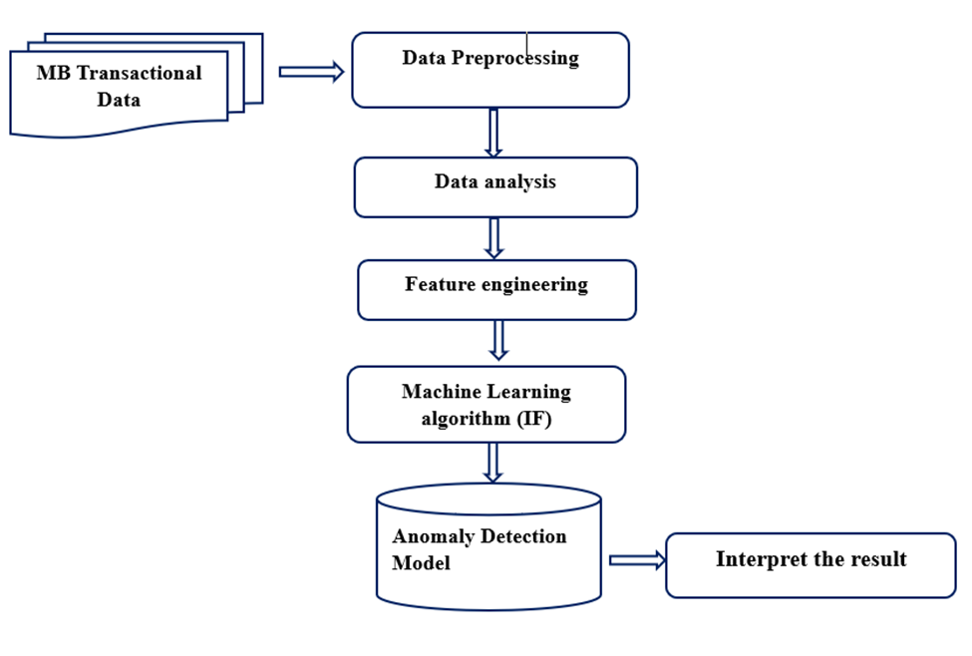
Figure 1: Architeccture of Anomaly detection using isolation forest

Literature Review
To achieve the objectives of this study, a comprehensive literature review was conducted to gain a deeper understanding of anomaly detection and the various techniques involved. This review provided detailed knowledge on different anomaly detection methodologies and their application in fraud detection within financial systems.

Research Design
This study employs an experimental research design to detect anomalies in transactional data using machine learning techniques. The experimental approach allows for systematic analysis and testing of different anomaly detection methods to identify irregular patterns in mobile banking transactions.

Data Collection
The transaction data for this study was extracted from the Commercial Bank of Ethiopia (CBE) Mobile Banking database, focusing on the period from July 1 to July 31, 2024. The data source, Arc Mob, provided detailed records of financial transactions performed through the platform. By analyzing this transaction data, insights into transaction volumes and trends within the mobile banking platform during the specified period were obtained.

Tools and Techniques
This study utilized various tools and techniques to perform experimental analysis. Python was chosen for its flexibility, ease of use, and extensive range of machine learning libraries, including the latest one, Flair. Additionally, PySpark, an advanced version of Python, was used to handle the large dataset efficiently. The transaction data underwent several preprocessing steps to organize, process, and analyze it, aligning with the project’s objectives.

CHAPTER FOUR

DATA COLLECTION, ANALYSIS AND DISCUSSION

Data Collection
For this study, a comprehensive dataset of 88,586,021 mobile banking transactions was extracted from the Arc Mob mobile banking transaction database, covering the period from June 1 to June 21, 2024. Due to resource constraints, processing the entire dataset was not feasible. Therefore, a subset of the data, consisting of transactions from a single week, was selected for analysis. This subset comprises 22,890,674 transactions, which will be utilized for conducting transactional data analysis and anomaly detection.
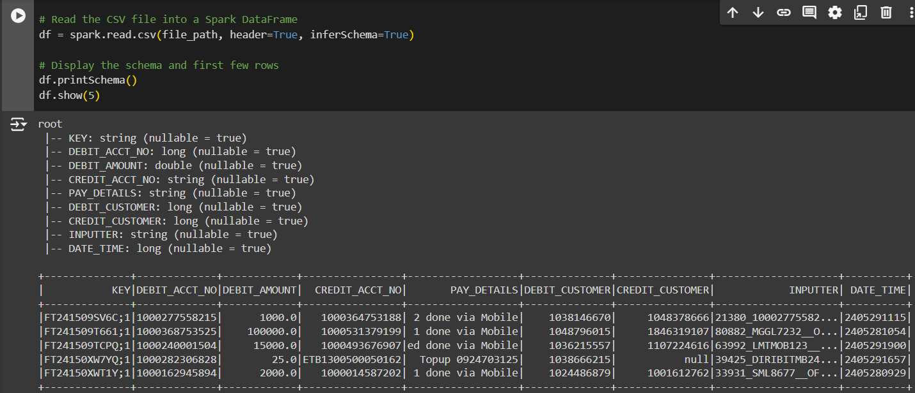
Figure 2: Extract data using python panda

Data preprocessing
To handle the large volume of data and address missing values and inconsistencies, we undertook several preprocessing steps to ensure the dataset was clean and consistent:
- Removing Transactions with Null Debit Amounts: We excluded transactions with null debit amounts since these were typically utility payments or reversals that did not contribute to meaningful analysis.
- Transforming Date-Time Columns: The date-time columns were converted into a standard date-time format, enabling us to perform accurate trend analysis over time.
- Changing Data Types for Consistency: We adjusted the data types of certain columns to ensure consistency throughout the dataset.
- Identifying Transaction Types: A new column was added to identify the type of each transaction, derived from the credit account information. This helped categorize transactions for better analysis.
- Dropping Irrelevant Columns: Columns that were not relevant to the study were dropped to streamline the analysis and focus on pertinent data.
- Excluding Other Bank Transactions: Transactions involving other banks were excluded, as we did not have access to the account details for these transactions. This limitation is noted under the scope and limitations of the study.
These preprocessing steps were crucial for preparing the data for further transactional analysis and anomaly detection, ensuring that the data used was reliable and meaningful.

Data Analysis
In this study, we have conducted various analyses to understand the transaction data and identify anomalies. The following sections detail the different types of analyses performed

Transaction Diversity
In this study, we have conducted various analyses to understand the transaction data and identify anomalies. The following sections detail the different types of analyses performed:
Number of Unique CREDIT_ACCT_NO: The main purpose of this analysis is to understand the diversity of transactions by counting the number of unique credit accounts. An unusually high or low number of unique credit accounts could indicate suspicious activity, such as money laundering or account fraud.
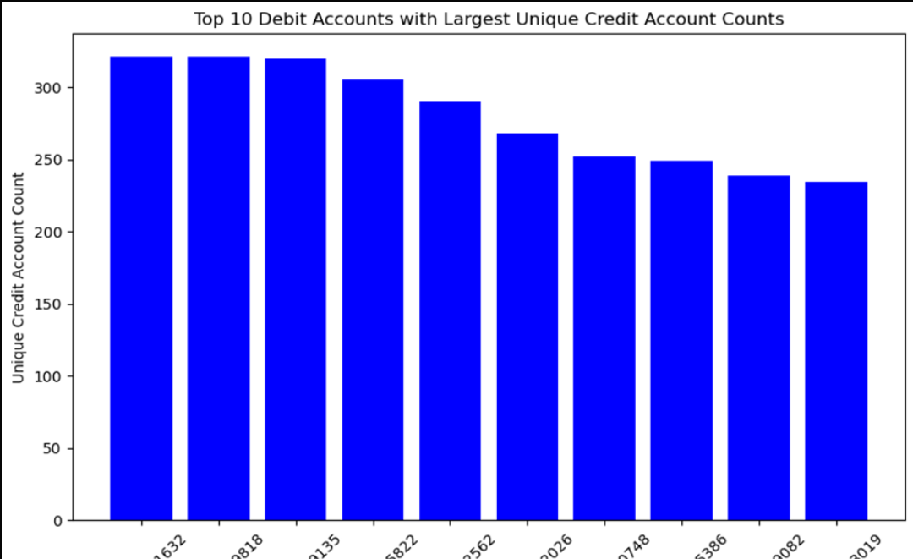
Figure 3:Unique number of credit Account per customer
The debit accounts shown in the chart exhibit high diversity, as indicated by the significant number of unique credit accounts associated with each. This suggests a diverse range of transactions for these accounts. Among the top debit accounts, such as **632, **818, and **135, each has around 300 unique credit accounts. This level of activity implies that these accounts are highly active and engage with a wide variety of different credit accounts. The chart effectively facilitates comparison by highlighting the transaction diversity among the top 10 debit accounts, enabling easy identification of those with the highest engagement.
Unique Transaction Types: The main purpose of this analytics is to understand the variety of transactions an account engages in. Unusual transaction types can be flagged as potential anomalies, indicating misuse or fraud.
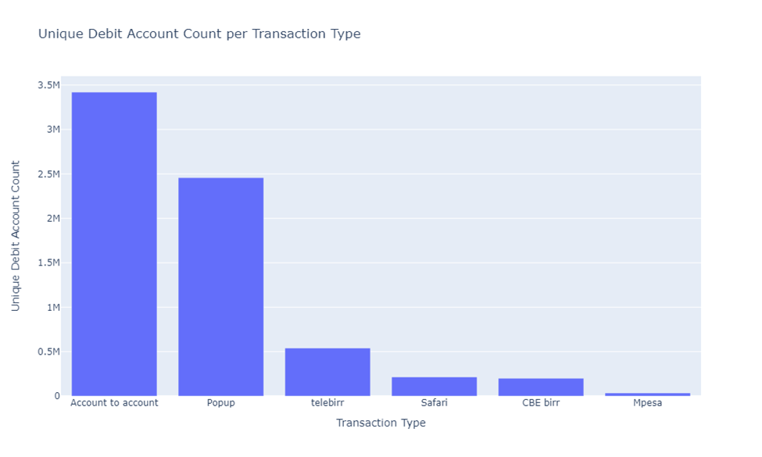
Figure 4: Unique number of transaction type by customer
The "Account to account" transaction type dominates with an overwhelmingly high total transaction amount, surpassing 200 billion, making it the most significant transaction type in terms of monetary value. In contrast, the total transaction amounts for "Mpesa," "Safari," "telebirr," "Popup," and "CBE birr" are significantly lower, contributing much less to the overall transaction volume. This distribution highlights the dominance of "Account to account" transactions and shows that other types contribute minimally in comparison. The high concentration of transaction value in "Account to account" transactions can be analyzed for anomalies, as any unexpected surges or drops in this category could indicate fraudulent activities. Understanding the distribution of transaction amounts across different types helps in profiling normal behavior and detecting anomalies when there are significant deviations from expected transaction amounts in any category.

4.2.1. Transaction Volume and Frequency
Analyzing transaction volume and frequency helps identify patterns and detect anomalies in transaction behavior. This involves measuring the total transaction amounts and the frequency of transactions for each debit account. By examining these metrics, we can spot accounts with unusually high or low transaction volumes and frequencies, which may indicate fraudulent activities or operational issues.

Distribution of transaction amount
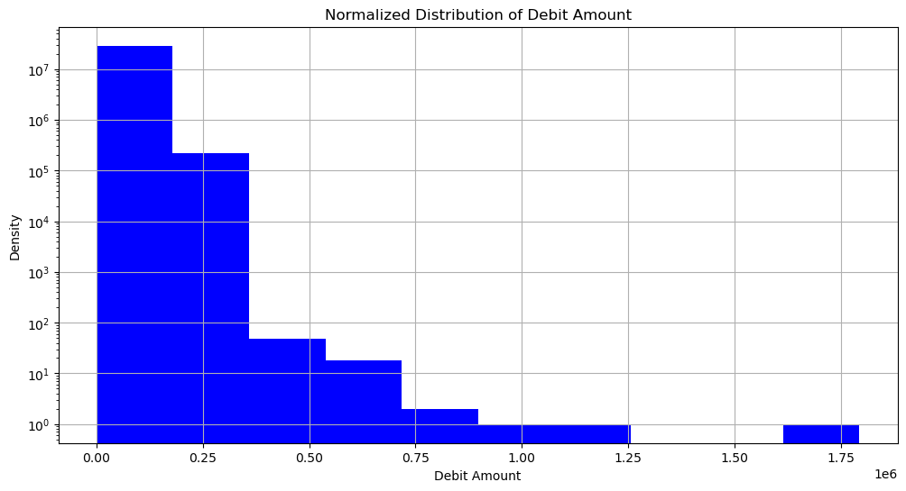
Figure 5: Distribution of transaction amount
The most prominent feature of this normalized debit amount distribution is the sharp peak at the lowest debit amount bin around 0.00, indicating a significant portion of transactions have very low debit amounts, which represents the "normal" behavior. However, the steep drop-off in frequency from this peak to the next few bins suggests an anomalous clustering of transactions with slightly higher debit amounts in the 0.25 to 0.75 range, which warrants further investigation.
Additionally, the presence of smaller spikes or bumps at certain higher debit amount values may signify anomalous events or patterns that deviate from the overall gradual decrease in frequency as the debit amount increases, and the very low number of transactions with debit amounts greater than 1.0 could also be considered an anomaly, potentially requiring analysis to understand the drivers behind such outliers. Closely examining the shape and characteristics of this distribution can uncover potential anomalies that provide valuable insights into the underlying business dynamics.

4.2.3. Transaction Patterns and Trends
We have analyzed the trend of transaction amounts and frequencies over different time periods, including hourly, weekly, and daily patterns. This analysis helps in understanding the typical behavior and identifying any deviations from the norm.
Hourly Transaction Trends: The purpose of this analysis is to understand transaction patterns on an hourly basis and identify peak activity hours. This analysis helps establish a baseline for normal transaction activity. Significant deviations from this baseline can indicate potential anomalies.
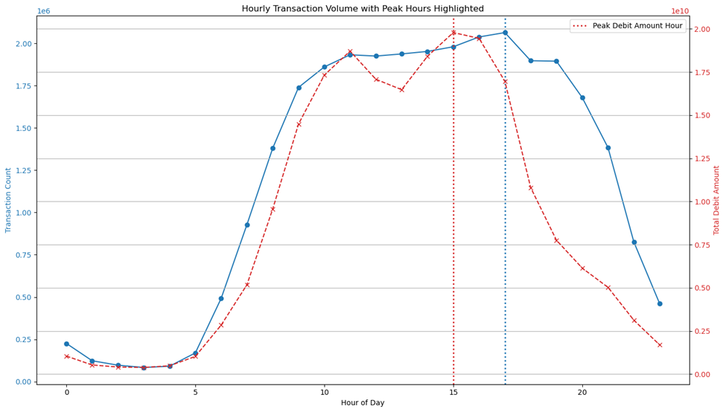
Figure 6:Houtly transaction count and Pike hour hightlight
The chart visualizes hourly transaction volume with peak hours highlighted. The blue line represents transaction counts per hour, while the red dashed line shows the total debit amount per hour. The vertical lines indicate peak hours for transaction counts and debit amounts. The transaction count steadily increases in the morning, peaks around midday, and then decreases towards the evening. The total debit amount follows a similar pattern, peaking slightly earlier in the afternoon. Highlighted peak hours show the times of highest transaction activity and debit amounts. Understanding normal hourly transaction patterns helps in identifying anomalies. Significant deviations, especially during off-peak hours, can indicate potential fraudulent activities or operational issues. This analysis is crucial for setting baselines and thresholds if needed.

Weekly Trends: The basic purpose of this analysis is to observe transaction behavior across different days of the week. Regular patterns help in spotting deviations that could signify anomalies, such as an unusual surge in transactions on typically low-activity days.
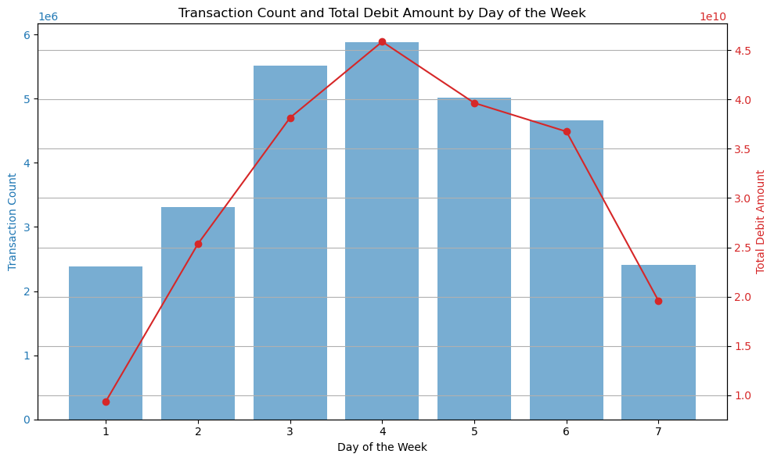
Figure 7: Weekly tend of Transaction count and amount
In this picture, the key anomalies to monitor are the significant spikes in transaction count and total debit amount on Thursdays, which stand out sharply from the rest of the weekly pattern, as well as the rapid declines observed from Thursdays to Fridays and through the weekend. The overall weekly cycle shows a consistent trend of steadily increasing activity from the beginning to the middle of the week, followed by a decline towards the weekend, with Mondays consistently having the lowest volumes. While this repeating weekly pattern represents the "normal" behavior, any deviations from this could be flagged as anomalies. Additionally, if the data were collected over a longer period, there may be opportunities to detect seasonal patterns or trends that would help differentiate between normal fluctuations and truly anomalous events, providing a more comprehensive understanding of the business dynamics.
Daily Trends : Purpose is to analyze daily transaction volumes and their variations. This analysis enables the detection of anomalies based on sudden changes in daily transaction volumes.
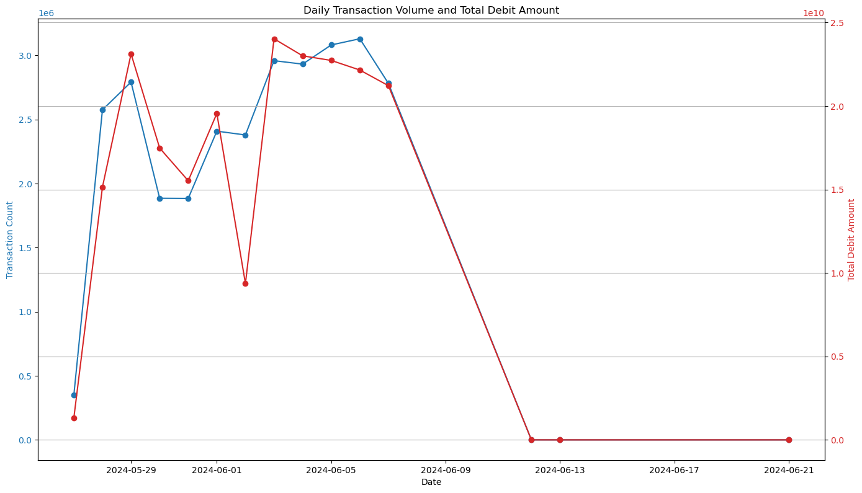
Figure 8: Daily trend of Transaction count and amount
The key anomalies observed in this data are the significant spike in transaction volume and total debit amount around June 1st, 2024, which represents a sharp deviation from the underlying cyclic pattern, and the subsequent rapid decline in these metrics reaching their lowest levels around June 13th. While the data exhibits a regular fluctuating trend, potentially on a weekly or monthly basis, these sudden changes in activity levels can be considered anomalous events that merit further investigation. Without additional context about the specific business operations or external factors, the root causes of these anomalies are unclear, but identifying and understanding such deviations from the norm could provide valuable insights to help the business adapt to changing conditions and optimize its operations.

Feature Extraction
Feature extraction is a pivotal step in anomaly detection, aiming to unveil intricate patterns in transaction behaviors for each debit account. For the Isolation Forest algorithm, we have meticulously crafted a set of features to enhance anomaly detection accuracy:
The DEBIT_ACCT_NO serves as the primary identifier for each account, linking transactions to their respective sources. The transaction type counts feature captures the frequency of different transaction types, offering insight into typical versus atypical activity patterns. The unique credit count tracks the number of distinct credit accounts interacted with, which may indicate unusual behavior if the count deviates significantly from the norm. The total transaction amount and average transaction amount features quantify the overall and average monetary values moved, crucial for detecting deviations from expected financial activity. The transaction_frequency measures how often transactions occur, and sudden changes in frequency can signal anomalies.

Debit amount deviation mean, Debit amount deviation min, Debit amount deviation max and Debit amount deviation standard deviation describe the statistical spread of transaction amounts, aiding in the detection of outliers. Time since last transaction (max ,min, mean and std) analyze the intervals between transactions, highlighting irregular patterns or gaps in activity that could indicate anomalies. These features collectively enable the Isolation Forest algorithm to effectively identify and isolate unusual transaction patterns. The change in transaction amount feature observes shifts in transaction size over time, identifying potential fraudulent patterns.
Lastly, the rolling average amount offers a smoothed average of transaction amounts over a rolling window, and the transaction velocity measures the speed at which transactions occur, both of which help in identifying unusual acceleration or deceleration in account activity. These generated features collectively enable a robust anomaly detection framework by capturing diverse aspects of transaction behavior, thereby enhancing the model’s ability to identify potential fraud.

Anomaly detection using Isolation forest
Isolation Forest detects anomalies by leveraging various features extracted from transactional data to construct multiple decision trees. Features such as total transaction amount, Transaction Frequency, and debit amount_deviation std are used to create splits in these trees. These splits help in partitioning the data, with anomalous transactions being isolated more rapidly due to their unusual patterns compared to typical transactions. For instance, high deviations in transaction amounts or irregular transaction intervals contribute to quicker isolation in the trees.
The algorithm generates an anomaly score based on the path length of each data point within these isolation trees. Anomalies, which exhibit rare or extreme behaviors, are isolated with shorter path lengths and thus receive higher anomaly scores. Conversely, normal transactions require more splits, resulting in longer path lengths and lower scores. Using these scores, the Isolation Forest assigns an anomaly label to each data point: a high score and label of anomaly (-1) indicate a likely outlier, while a low score and label of normal (1) suggest that the data point conforms to expected patterns. This approach allows for effective identification and classification of anomalous transactions within the dataset.
From among 4,298,320 transaction per debit account 42,982 accounts have detected as having anomaly transaction where as 4,255,338 accounts have detected as having normal transaction .
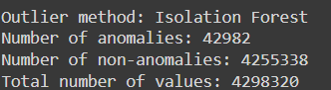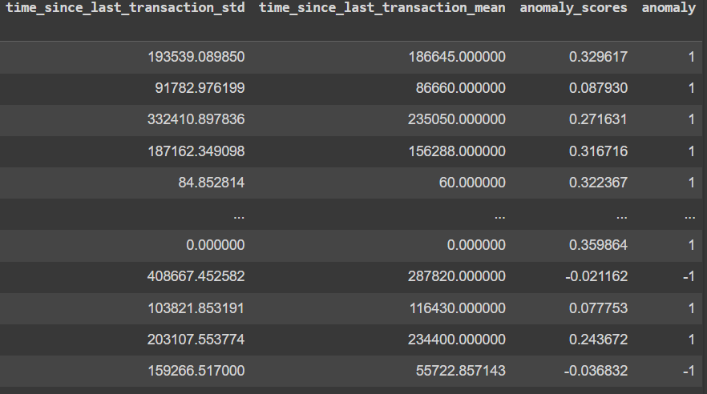
Figure 9:Isolation Forest Model Result

    - Feature Selection
The correlation analysis between the selected features and the anomaly score has provided critical insights into the factors that most strongly influence whether a transaction is classified as anomalous. The feature total_transaction_amount exhibits a high absolute correlation with the anomaly score, indicating that transactions involving larger amounts are more likely to be flagged as anomalous. This suggests that high transaction values are a key indicator of potential fraud or irregular activity.
The feature debit_amount_deviation_std measures the standard deviation of debit amounts, and its significant correlation with anomalies suggests that accounts with high variability in transaction amounts are more prone to anomalies. This variability is essential in identifying deviations from typical transaction patterns, which are often indicative of suspicious behavior.
change_in_transaction_amount captures sudden shifts in transaction amounts, which are frequently associated with fraudulent activity. This feature’s strong correlation with anomalies underscores the importance of monitoring abrupt changes in transaction behavior as a potential sign of fraud.
The feature debit_amount_deviation_max represents the maximum deviation in debit amounts, and its relevance to anomalies highlights the role of unusually high transactions in identifying irregularities. Such deviations from the norm are often red flags for potential fraudulent transactions.
average_transaction_amount is another crucial feature, as anomalies are often associated with transactions that deviate from the expected average amounts. Transactions with unusually high or low average values compared to typical account behavior can be indicative of suspicious activity.
Finally, rolling_avg_amount tracks the moving average of transaction amounts over time, allowing for the detection of trends and deviations. This feature is particularly useful in identifying gradual shifts in transaction behavior that may lead to anomalous activities. By continuously monitoring changes in transaction patterns, this feature helps in the early detection of potentially fraudulent activities.

Model result interpretation
To gain insights from the model results, we analyzed key relationships between various transaction features to differentiate normal accounts from anomalous ones

Total Transaction Amount vs. Debit Amount Deviation std
The puprouse of this analysis is to examine how the total transaction amount relates to the standard deviation of debit amounts. This can help identify if high transaction amounts are associated with greater variability in debit amounts.
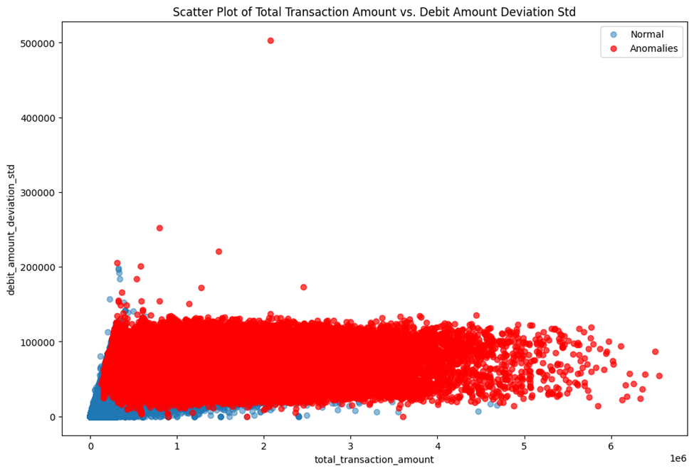
Figure 10: Total Transaction Amount vs. Debit Amount Deviation std
The scatter plot reveals a clear relationship between total transaction amount and debit amount deviation standard deviation, with data points color-coded to differentiate between normal transactions (blue) and anomalies (red). Most data points cluster at lower values of both features, indicating that smaller transactions with low variability are typically classified as normal. In contrast, anomalies are more dispersed, particularly at higher values of total transaction amount and debit amount deviation standard deviation. This suggests that larger transactions with greater variability in amounts are more likely to be flagged as anomalies. The distinct separation between normal and anomalous transactions, especially at higher ranges, highlights a strong negative correlation between these features and the anomaly score.

Average Transaction Amount vs. Change in Transaction Amount
The purpose of this analysis is to explore the relationship between the average transaction amount and changes in transaction amounts. This helps in understanding if significant changes in transaction amounts are associated with high average transaction amounts.
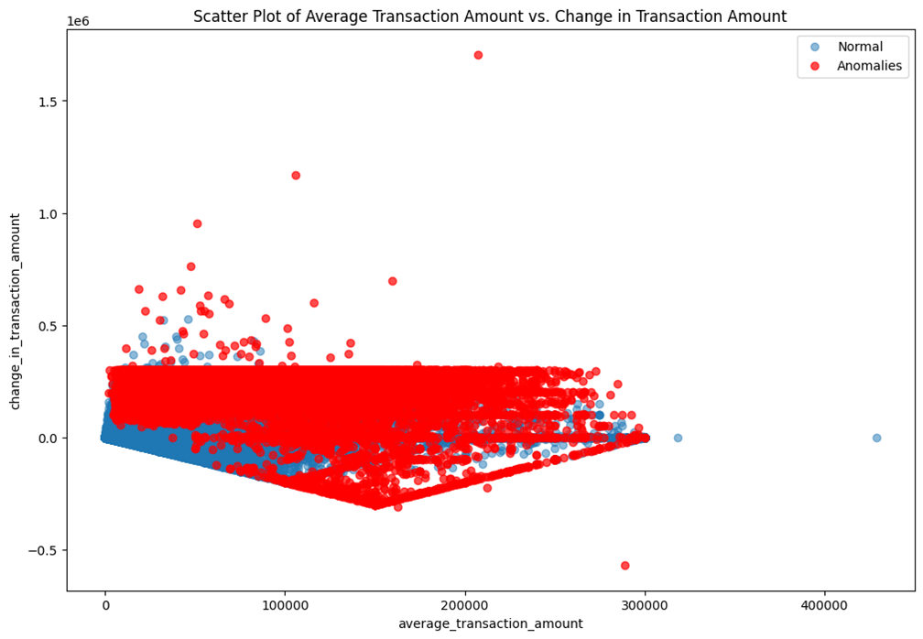
Figure 11: Average Transaction Amount vs. Change in Transaction Amount
The scatter plot displays the relationship between the average transaction amount and the change in transaction amount, with data points color-coded to distinguish between normal transactions (blue) and anomalies (red). Most normal transactions cluster at lower values on both axes, indicating that typical transactions involve smaller amounts with minimal changes. In contrast, the anomalies are more dispersed, particularly at higher values of both average transaction amount and change in transaction amount, suggesting that transactions involving larger amounts and significant changes are more likely to be flagged as suspicious. The wide spread of anomalous points, including some at extreme values, further emphasizes that unusual or large fluctuations in transaction amounts, coupled with higher averages, are key indicators of anomalous behavior.

Rolling Average Amount vs. Transaction Velocity
The purpose of this analysis is to analyze how the rolling average of transaction amounts correlates with the velocity (rate of transactions). This can help identify if rapid transactions (high velocity) are consistent with a high rolling average or if there are deviations.
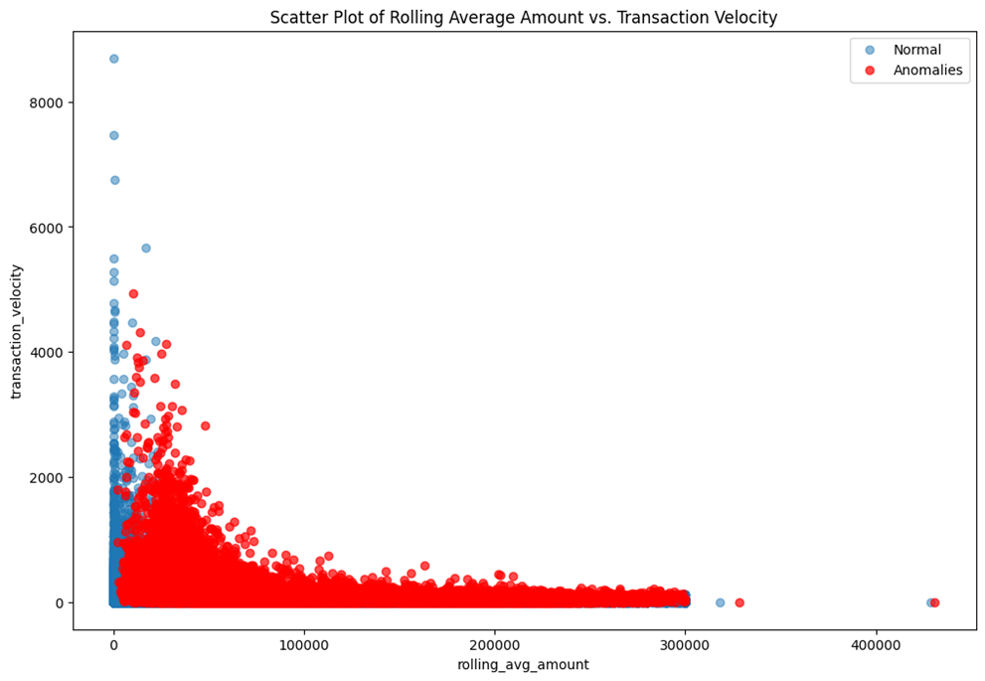
Figure 12: Rolling Average Amount vs. Transaction Velocity
The scatter plot illustrates the relationship between the rolling average amount (x-axis) and transaction velocity (y-axis), with normal transactions depicted as blue points and anomalies as red points. Key observations from the plot include a significant concentration of both normal and anomalous transactions at the lower end of both the rolling average amount and transaction velocity, indicating that most transactions are characterized by low rolling averages and low velocities. Anomalous transactions (red points) are more dispersed, especially at lower rolling average amounts, with a notable presence of higher velocities. However, at higher rolling average amounts, anomalies become sparse, suggesting that fewer transactions are flagged as anomalies.

The plot indicates that a higher transaction velocity is often associated with anomalous behavior when the rolling average amount is low. Conversely, as the rolling average amount increases, transaction velocity tends to decrease, with fewer anomalies observed.

Total Transaction Amount vs. Rolling Average Amount
The purpose of this analysis is to compare the total transaction amount with the rolling average of transaction amounts.This can reveal if large total transaction amounts are consistent with a high rolling average or if there are discrepancies.
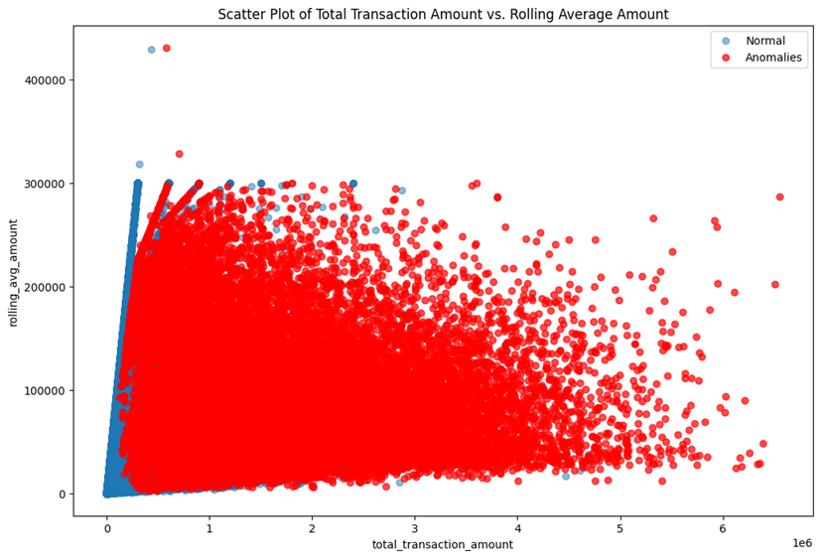
Figure 13: Total Transaction Amount vs. Rolling Average Amount
Normal transactions, depicted as blue points, are densely clustered at lower values for both metrics, indicating that most smaller transactions follow expected patterns. In contrast, anomalous transactions (red points) are more widely dispersed, especially at higher values of both total transaction amount and rolling average amount. This dispersion suggests that larger transactions are more frequently flagged as anomalies due to significant deviations from typical behavior. The spread of red points across various levels of the rolling average indicates that the anomaly detection method is sensitive to large deviations, highlighting the need for close monitoring of such transactions. Overall, the plot shows a trend where increasing total transaction amounts and rolling averages are associated with a higher prevalence of anomalies.

Debit Amount Deviation Max vs. Average Transaction Amount
The purpose of this analysis is to explore the relationship between the maximum deviation in debit amounts and the average transaction amount.This helps in understanding if higher deviations are present for accounts with higher average transaction amounts.
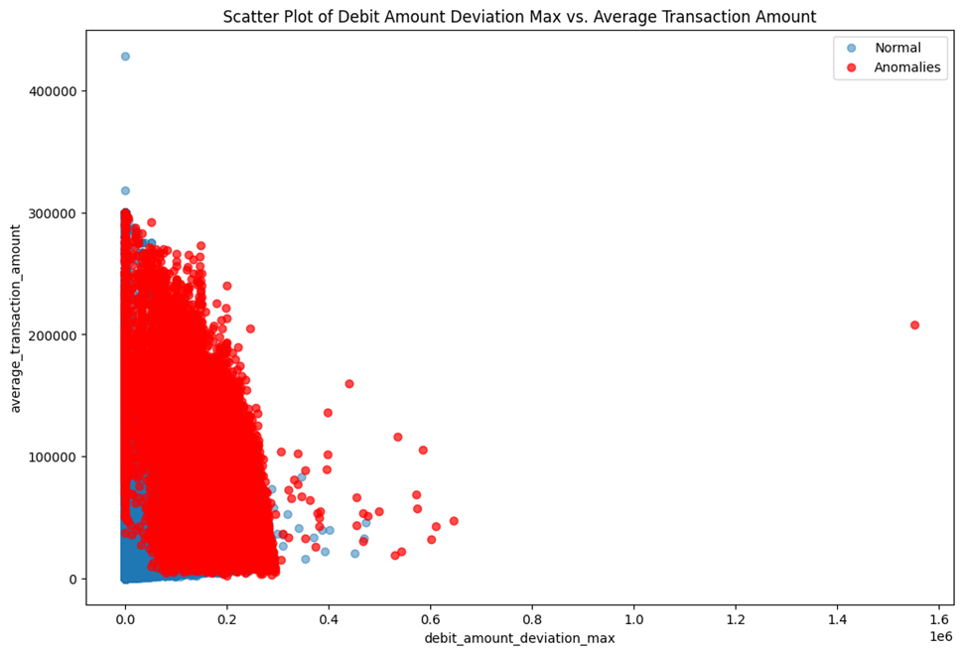
Figure 14: Debit Amount Deviation Max vs. Average Transaction Amount
The plot illustrates the relationship between Debit Amount Deviation Max (x-axis) and Average Transaction Amount (y-axis), with data points categorized as either normal (blue) or anomalies (red). Normal transactions, represented by blue points, are predominantly clustered at lower values for both metrics, indicating that typical transactions have minimal deviations and stay within an expected range. In contrast, anomalous transactions (red points) are more dispersed, with some extreme outliers. Anomalies are observed even at lower debit amount deviation max values, but they also extend to higher values, suggesting that larger deviations in debit amounts are often associated with atypical or potentially fraudulent transactions. The plot reveals that while anomalies can occur across various levels of debit amount deviation max, there is a significant concentration of red points at higher deviations, indicating these transactions require closer examination. Additionally, a few extreme outliers with very high deviations and average transaction amounts are all classified as anomalies, possibly pointing to fraudulent activities or substantial errors. Overall, the trend shows that as the debit amount deviation max increases, the average transaction amount also tends to rise, with a higher likelihood of being flagged as an anomaly.

CHAPTER FIVE

CONCLUSION AND RECOMMENDATION

Conclusion
This study demonstrates the effectiveness of the Isolation Forest algorithm in detecting anomalies within mobile banking transactions. By analyzing a large dataset of over 22 million transactions, the algorithm successfully identified 42,982 potentially anomalous debit accounts, highlighting its utility in flagging irregular activities that could signal fraud or operational issues. The research emphasizes the importance of selecting relevant features, such as transaction frequency, total transaction amount, debit amount deviations, and transaction modes, to enhance the algorithm's accuracy. The results confirm that Isolation Forest is a robust, scalable tool suitable for high-dimensional financial data, making it a valuable asset for enhancing security in mobile banking systems. This approach not only aids in early detection of potential threats but also contributes to the overall integrity and reliability of financial transactions. The findings suggest that integrating advanced anomaly detection algorithms like Isolation Forest into mobile banking platforms can significantly improve their ability to safeguard against fraudulent activities and operational disruptions, ensuring a more secure and trustworthy banking environment for users.

Recommendation
Based on the finding of the research the following recommendations given:
- Focus on transactions with high variability and larger amounts as these are more likely to indicate fraudulent behavior. Consider setting specific thresholds for these features to improve detection accuracy.
- Investigate transactions with significant fluctuations in amount, especially when combined with high average transaction amounts. Adjust detection rules to prioritize such patterns.
- Monitor transactions with high velocity and low rolling averages closely. Implement controls to flag transactions that deviate from typical velocity patterns, especially when rolling averages are low.
- Pay special attention to transactions that are both high in total amount and rolling average. Establish more rigorous monitoring for these cases to catch potential fraud.
- Focus on transactions with high deviations and average amounts. Implement a more nuanced approach to flag transactions with significant deviations, especially those with extreme values.
- Focus on High-Risk Transactions: Set up monitoring systems to alert on transactions that exhibit both high total amounts and high variability in debit amounts. Ensure that anomalies in these areas are reviewed promptly.
- Velocity Alerts: Implement alerts for high transaction velocities, especially when the rolling average amount is low. This can help catch rapid, potentially fraudulent activities.

REFERENCES
Agarwal, R. ,. (2019). Mobile banking adoption: Key challenges and opportunities. ournal of Internet Banking and Commerce, 24(2), 1-15.
Aggarwal, C. C. (2016). Outlier analysis (2nd ed.).
Ahmed, M. H., & Wong, K. (2016). A survey of network anomaly detection techniques. . Journal of Network and Computer Applications, 60, 19-31.
Behera, R. K., & Nayak. (2020)). Advanced anomaly detection in mobile banking: Leveraging machine learning for fraud prevention. Journal of Financial Crime, 27(2), 567-589.
Bolton, R. J., & Hand, D. J. (2002). Statistical fraud detection: A review. . Statistical Science, 17(3), 235-255.
Chandola, V. B., & Kumar, V. (2009). Anomaly detection: A survey. ACM Computing Surveys. ACM Computing Surveys, 41(3), 1-58.
Commercial Bank of Ethiopia. (2024, Aug). Retrieved from Commercial Bank of Ethiopia: https://combanketh.et/en/
Delamaire, L. A., & De Ryck, N. (2009). Credit card fraud and detection techniques: Review. Banking and Finance Review, 1-13.
Hodge, V. J., & Austin, J. (2004). A survey of outlier detection methodologies. Artificial Intelligence Review , 22(2), 85-126.
Hyndman, R. J., & Athanasopoulos, G. .. (2018). Forecasting: principles and practice.
Klapper, L. S., & Hess, J. (2018). Measuring financial inclusion and the fintech revolution. World Bank Group. . The global Findex database .
Kumar, S. G., & Rajasekaran, J. (2018). A survey of fraud detection techniques in mobile banking. International Journal of Computer Applications, 180(26), 13-18. .
Liu, F. T., & Zhou, Z. H. (2008). Isolation forest. . In Proceedings of the Eighth IEEE International Conference on Data Mining (ICDM 2008), pp. 413-422.
Mertens, M. N., & Adekoya, A. ,. (2019). The impact of mobile banking on financial inclusion in remote and underserved communities. Journal of Developmental Economics, 45(3), 159-176.
Mouratidis, H. G., & Dritsas, S. (2020). Compliance management in mobile financial services: A review of regulatory requirements and support mechanisms. Journal of Financial Regulation and Compliance, 28(2), 203-223.
Phua, C. L., & Gayler. (2010). A comprehensive survey of data mining-based fraud detection research. Artificial Intelligence Review, 34(1), 1-14.
Rokach, L. (2010). Ensemble-based classifiers. World Scientific Publishing Company.
Shaikh, A. A., & Karjaluoto, H. ,. (2015). Mobile banking adoption: A literature review. Telematics and Informatics, 32(1), 129-142.
Soo, H. L., & Kim, S. (2018). Enhancing security measures in mobile banking: The role of multi-factor authentication and encryption. Journal of Financial Security, 10(4), 223-237.
Xia, Y., & Xu, X. (2018). A comprehensive review of anomaly detection with applications in financial fraud. Mathematical Problems in Engineering, 1-20.

